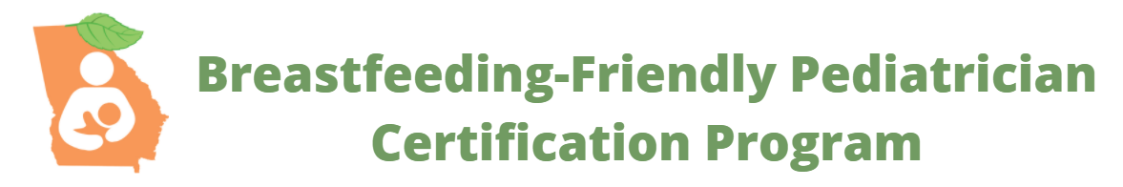

Frequently Asked Questions
Who can participate?
Primary care pediatricians practicing in the state of Georgia who want to vet or improve their fund of lactation knowledge and clinical skills to better help breastfeeding families.
What steps are involved?
Fill out an interest form here , join or renew your membership in the Georgia Chapter- American Academy of Pediatrics here, and we will send you a self-assessment to complete. After you review your self-assessment report and reflect on changes to your practice that you might wish to implement, you are invited to submit a formal application to document that you are adherent to the practices outlined in the AAP’s 2017 Clinical Report The Breastfeeding Friendly Pediatric Practice.
Why should I participate?
Candidates receive curated, high-yield resources, recognition on our social media channels, and access to pediatrician IBCLCs/breastfeeding medicine specialists to help with specific questions or clinical concerns. Once you are a certified as a Breastfeeding-Friendly Pediatrician, we will provide a framed certificate, digital logos for your website and social media, features on our social media channels, and inclusion on both the Georgia Breastfeeding Coalition website and the Georgia Chapter AAP website.
Who is sponsoring the program?
The Breastfeeding-Friendly Pediatrician Certification Program is a partnership between the Georgia Chapter- American Academy of Pediatrics and the Georgia Breastfeeding Coalition.
Where can I learn more?
Visit our websites at www.GaAAP.org/breastfeeding and follow us on Instagram.
To whom may I direct my questions? Christie Jean, Program Coordinator, Georgia Chapter AAP, cjean@gaaap.org can field and direct your questions.

